**Final Report of Traineeship Program 2024**

*On*

“Analysis of Chemical Components”

**MEDTOUREASY**



25th July 2024



# ACKNOWLDEGMENTS

The traineeship opportunity that I had with MedTourEasy was a great change for learning and understanding the intricacies of the subject of Data Visualizations in Data Analytics; and also, for personal as well as professional development. I am very obliged for having a chance to interact with so many professionals who guided me throughout the traineeship project and made it a great learning curve for me.

Firstly, I express my deepest gratitude and special thanks to the Training & Development Team of MedTourEasy who gave me an opportunity to carry out my traineeship at their esteemed organization. Also, I express my thanks to the team for making me understand the details of the Data Analytics profile and training me in the same so that I can carry out the project properly and with maximum client satisfaction and also for spearing his valuable time in spite of his busy schedule.

I would also like to thank the team of MedTourEasy and my colleagues who made the working environment productive and very conducive.



# TABLE OF CONTENTS

Acknowledgments i

Abstract iii

|  |  |  |
| --- | --- | --- |
| **Sr. No.** | **Topic** | **Page No.** |
| **1** | Introduction |  |
|  | 1.1 About the Company | 5 |
|  | 1.2 About the Project | 5 - 6 |
|  | 1.3 Objectives and Deliverables | 7 - 8 |
| **2** | Methodology |  |
|  | 2.1 Flow of the Project & Use Case Diagram | 9 |
|  | 2.2 Data Preprocessing & Techniques Used: t-SNE and Bokeh | 10 |
|  | 2.3 Tokenization and Document-Term Matrix | 11 |
| **3** | Implementation |  |
|  | 3.1 Importing and Inspecting the Dataset | 12 - 13 |
|  | 3.2 Filtering and Tokenizing Ingredients | 13 - 14 |
|  | 3.3 Document-Term Matrix Initialization | 14 - 15 |
|  | 3.4 Dimensionality Reduction using t-SNE | 15 - 16 |
|  | 3.5 Visualizing Ingredient Similarity with Bokeh | 16 - 17 |
|  | 3.6 Adding Hover Tool for Enhanced Interaction | 17 - 18 |
|  | 3.7 Literature Review | 19 - 20 |
| **4** | Results and Analysis |  |
|  | 4.1 Mapping the cosmetic items | 21 - 22 |
|  | 4.2 Ingredient Similarity Visualization | 22 - 23 |
|  | 4.3 Comparing Similar Cosmetic Products | 24 |
| **5** | Conclusion | 25 |
| **6** | Future Scope | 26 |
| **7** | References | 27 |



# ABSTRACT

The cosmetic industry has seen significant growth in recent years, driven by consumers seeking products that align with their specific skin concerns and ingredient preferences. However, the overwhelming amount of information on product labels, particularly complex ingredient lists, poses a challenge for consumers when selecting suitable skincare products. This project addresses this issue by developing a **content-based recommendation system** for cosmetic products, focusing on ingredient similarity. Using data from Sephora, the system processes ingredient lists to recommend alternatives with similar compositions. The project employs **t-SNE** for dimensionality reduction to map high-dimensional ingredient data into a 2D space, making it easier to visualize product similarities. **Bokeh** is used to create interactive visualizations, allowing users to explore and compare products based on their ingredient content.

The core objectives of this system are to help consumers make informed choices and find alternatives that suit their skin type while avoiding harmful or undesired ingredients. The recommendation system not only simplifies the process of analyzing complex ingredient lists but also provides users with a user-friendly interface to interactively explore cosmetic product options. This report outlines the methodology, data preprocessing, dimensionality reduction techniques, and implementation of the system, along with a discussion on the results and future scope for enhancing the recommendation model.

Selecting new cosmetic products, especially for individuals with sensitive skin, can be a challenging and sometimes daunting task. The complexity of ingredient lists, which are typically presented in technical and chemical terms, makes it difficult for consumers to understand which products are safe and effective for their skin. This project aims to alleviate this problem by building a **content-based recommendation system** for cosmetic products based on ingredient similarity. Leveraging data from 1,472 cosmetics listed on Sephora, the project focuses on **moisturizers** for **dry skin** and processes the ingredient lists to offer personalized product recommendations.



# Introduction

## About the Company

MedTourEasy, a global healthcare company, provides you the informational resources needed to evaluate your global options. MedTourEasy provides analytical solutions to our partner healthcare providers globally.

## About the Project

The Content-Based Recommendation System for Cosmetics project addresses a common challenge faced by consumers in selecting cosmetic products that align with their skin type and ingredient preferences. With an increasing awareness of the ingredients used in skincare products, many individuals seek transparency and guidance in their purchasing decisions. This project aims to simplify the decision-making process by providing a tool that recommends cosmetic products based on their ingredient similarities.

The project focuses on moisturizers suitable for dry skin, utilizing a dataset of 1,472 cosmetic products from Sephora. By analyzing the ingredient lists of these products, the system identifies potential alternatives that share similar compositions. This approach not only aids consumers in making informed choices but also enhances their understanding of cosmetic ingredients.

Key Features:

1. Data Processing: The project begins with data collection and preprocessing, which includes cleaning the dataset and organizing the ingredient information for each product.
2. Tokenization: Ingredients are tokenized and processed to create a comprehensive vocabulary that facilitates the analysis of similarities among products.
3. Document-Term Matrix: A Document-Term Matrix (DTM) is constructed to represent the frequency of ingredients in each product, allowing for a quantitative analysis of ingredient composition.
4. Dimensionality Reduction with t-SNE: To visualize the high-dimensional data, the project employs t-SNE, reducing the dimensionality of the DTM to two dimensions. This enables easy comparison and visualization of product similarities.



Objectives**:**

The primary objectives of this project include:

* + Helping consumers navigate complex ingredient lists by providing clear and actionable recommendations.
  + Enabling users to find suitable cosmetic alternatives based on their current preferences and skin concerns.
  + Promoting awareness and understanding of the importance of cosmetic ingredients in skincare.

This project serves as a valuable tool for consumers seeking to make informed choices in the cosmetic market. By leveraging data science and visualization techniques, it not only simplifies the selection process but also empowers individuals to choose products that best fit their needs and concerns. Future enhancements could include expanding the product categories, integrating user reviews, and conducting toxicity analyses to further improve the recommendation system.



## Objectives and Deliverables

### Objectives:

1. **Development of a Content-Based Recommendation System**:
   * Create a robust system that utilizes ingredient similarity to recommend cosmetic products. The recommendation engine will analyze the composition of various moisturizers, focusing on those suitable for dry skin, and suggest alternatives based on similar ingredients.

### Empower Consumers to Compare Products:

* + Provide users with the ability to easily compare multiple cosmetic products side by side. This feature will allow consumers to make informed decisions by assessing key attributes such as ingredient profiles, effectiveness, and suitability for their skin type.

### Enhance User Understanding of Ingredients:

* + Educate consumers about the importance of cosmetic ingredients by highlighting their functions and potential benefits or risks. This will help users develop a better understanding of what they are applying to their skin.

### Facilitate Personalized Recommendations:

* + Tailor the recommendation system to consider individual preferences, such as skin type and specific ingredient avoidance (e.g., allergens or irritants). This personalization will improve user satisfaction and trust in the recommendations provided.

### Interactive Visualization of Similarities:

* + Create an engaging and intuitive visual representation of product similarities using dimensionality reduction techniques. The visualization will help users grasp complex ingredient relationships more easily.



### Deliverables:

1. **Document-Term Matrix (DTM)**:
   * A structured matrix that captures the frequency of ingredients across various cosmetic products. This DTM will serve as the foundation for subsequent analysis, enabling the calculation of ingredient similarities.

### Dimensionality Reduction Visualization:

* + Implementation of the t-SNE algorithm to reduce the high-dimensional data of the DTM into a two-dimensional space. This will facilitate easier analysis and interpretation of ingredient similarities among products.

### Interactive Scatter Plot:

* + A visually appealing scatter plot created using Bokeh, allowing users to interact with the data. Features will include:
    - **Hover Functionality**: Users can hover over points to view detailed information about each product, including its name, brand, price, and key ingredients.
    - **Customization Options**: Users may filter the visualization based on specific criteria, such as product type or brand.

### Ingredient Comparison Tool:

* + A feature enabling users to select multiple products and compare their ingredient lists side by side. This will highlight similarities and differences, aiding users in making informed choices about their skincare products.

### Comprehensive Project Documentation:

* + A detailed report that outlines the entire project process, including data collection, preprocessing, methodology, results, and analysis. This documentation will serve as a reference for future improvements and for those interested in replicating or building upon the project.

### Future Scope Recommendations:

* + Suggestions for potential enhancements to the recommendation system, including integrating user reviews, expanding to additional product categories, and conducting toxicity analyses to flag harmful ingredients. This will provide a roadmap for future development efforts.



# METHODOLOGY

## Flow of the Project & Use Case Diagram

The project followed a structured workflow designed to ensure systematic development and analysis. It began with **data collection**, utilizing the cosmetics dataset from Sephora, followed by **data preprocessing** to filter and clean the data. The focus was narrowed to moisturizers suitable for dry skin. **Tokenization** of ingredients was performed to break down complex ingredient lists into manageable components, which were then utilized to create a **Document-Term Matrix (DTM)**. Following this, **dimensionality reduction** techniques, specifically t-SNE, were applied to visualize ingredient similarities effectively. The final step involved using Bokeh for interactive visualization, providing users with a platform to explore and compare products based on their ingredient compositions.

The system supports various use cases that cater to different stakeholders, including:

* **Consumers**: Individuals searching for alternative moisturizers with similar ingredients that align with their skin type and personal preferences.
* **Dermatologists**: Professionals analyzing common ingredients in a patient’s skincare routine, allowing them to offer informed recommendations and insights.
* **Researchers**: Academics investigating the prevalence and impact of certain chemicals across skincare products, contributing to broader studies on cosmetic safety and efficacy.
* **Retailers**: Businesses aiming to enhance product offerings by understanding consumer preferences based on ingredient analysis.

This diverse range of use cases highlights the system's versatility and potential impact across different sectors.



## Data Preprocessing & Techniques Used: t-SNE and Bokeh

The preprocessing phase involved several key steps crucial for ensuring the dataset was clean and ready for analysis:

1. **Filtering the Dataset**: The dataset was filtered to isolate products labeled as "Moisturizers" specifically targeting consumers with dry skin. This narrowed focus ensured the subsequent analysis was relevant to the intended audience.
2. **Resetting the Index**: The index of the DataFrame was reset to facilitate easier manipulation of the data, allowing for straightforward referencing and data handling during the analysis.
3. **Tokenization of Ingredients**: Ingredients were tokenized to break down complex ingredient lists into individual components. This process involved converting all text to lowercase and splitting the strings based on a specified delimiter (', '), resulting in a list of individual ingredients for each product.
4. **Data Cleaning**: Additional cleaning steps included removing any duplicates, handling missing values, and ensuring consistent formatting across the dataset. This comprehensive cleaning was essential for generating accurate and reliable recommendations.

The preprocessing efforts ensured that the data was not only clean but also well-structured for subsequent analysis, which is critical for generating accurate recommendation outputs.

The project employed two key techniques for analysis and visualization:

* **t-SNE (t-Distributed Stochastic Neighbor Embedding)**: This technique was crucial for reducing the dimensionality of the ingredient space. By mapping each product to a two- dimensional space based on ingredient similarity, t-SNE facilitated the visualization of relationships between products, making it easier to identify clusters and similarities among moisturizers.
* **Bokeh**: Bokeh was utilized to create an interactive visualization platform. The library allowed for the development of an engaging scatter plot that displayed product details dynamically when users interacted with the data points.



## Tokenization and Document-Term Matrix

To quantify the presence of each ingredient in a product, the following steps were implemented:

**Tokenization**: Each product's ingredient list was processed to extract individual ingredients. This involved converting the ingredient string to lowercase and splitting it into a list of tokens based on a predefined delimiter.

**Document-Term Matrix (DTM) Initialization**: A matrix of zeros was initialized to represent the presence (or absence) of each ingredient in each product. The dimensions of the matrix were determined by the number of products in the dataset (rows) and the total number of unique ingredients identified (columns). This matrix served as the foundation for subsequent ingredient-based analysis, allowing for the quantification of ingredient similarities across different products.



# IMPLEMENTATION

The overall goal of the project is to build a system that can recommend cosmetic products (specifically moisturizers for dry skin) based on ingredient similarity. This system will allow consumers to compare products and find alternatives, especially when they are looking for specific ingredients in their skincare routine.

## Importing and Inspecting the Dataset

### Step Explanation:

The first step is loading the dataset into Python for analysis. The dataset contains product details from Sephora, including product name, brand, price, and a list of ingredients for each product.

* **Pandas Library**: We use the Pandas library to import the dataset and inspect its structure.
* **Data Inspection**: It's crucial to inspect the dataset by displaying a few rows and checking for any missing values or inconsistencies. We also check the different categories of products available, such as "Moisturizers," "Cleansers," etc., by counting the frequency of each product type.

### Key Points:

* **Data Loading**: We use Pandas to read the CSV file into a DataFrame.
* **Basic Inspection**: We display the first few rows to understand how the data is structured.
* **Understanding Labels**: We count how many products belong to each label (e.g., moisturizer, cleanser, etc.) to ensure we have sufficient data for the analysis.

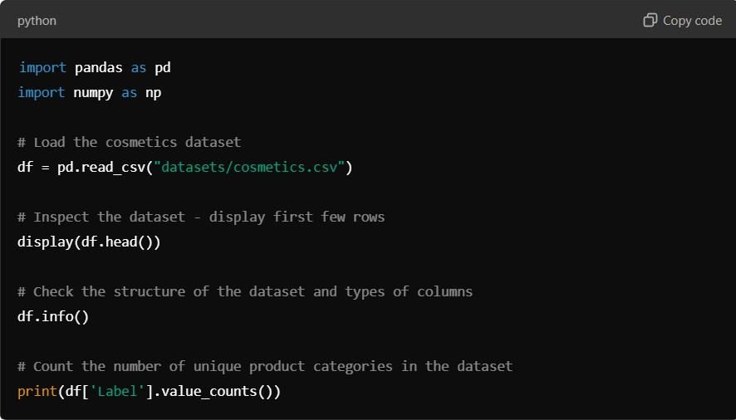

## Filtering and Tokenizing Ingredients

### Step Explanation:

In this step, we filter the dataset to focus on a specific product category — in this case, "Moisturizers" that are suitable for dry skin. This helps narrow down our analysis and provides a more specific recommendation system.

* **Filtering**: Filtering is performed to extract only the products labeled as “Moisturizer” for dry skin, as we aim to build a recommendation system for this specific category.
* **Tokenizing Ingredients**: We split the ingredients of each product into individual components, creating a list of ingredients. This step is essential because it converts the unstructured ingredient list into a more structured format that can be analyzed. We use the .split() function to separate ingredients based on a delimiter, which is typically a comma.

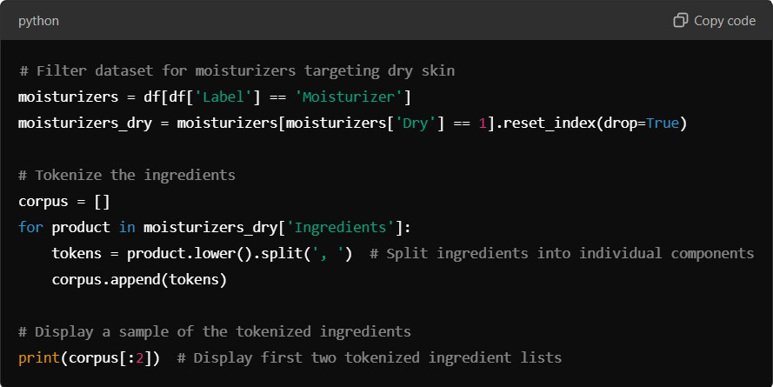

### Key Points:

* **Filtering**: We focus only on moisturizers labeled for dry skin by using condition-based filtering.
* **Tokenization**: Breaking the ingredient list into individual components allows us to treat each ingredient as a feature for analysis.

The dataset was filtered to focus on a specific category of products, such as "Moisturizers" for dry skin. The ingredients for each product were then tokenized, converting each list of ingredients into individual components to form a corpus for further analysis.

## Document-Term Matrix Initialization

### Step Explanation:

The **Document-Term Matrix (DTM)** is a fundamental part of text analysis. In our case, each product’s ingredient list is like a “document,” and each ingredient is a “term.” The DTM represents which ingredients are present in each product.

* **Matrix Representation**: We initialize a matrix where each row represents a product and each column represents a unique ingredient across all products. A "1" in the matrix means the ingredient is present in the product, while a "0" indicates absence.
* **CountVectorizer**: We use **CountVectorizer** from the scikit-learn library to build this matrix automatically. It tokenizes the text and creates a matrix where each column represents a unique ingredient and each row represents a product.

### Key Points:

* **Document-Term Matrix (DTM)**: This matrix is the foundation for comparing products based on ingredient similarity.
* **Binary Representation**: The matrix encodes whether an ingredient is present or not in each product, enabling quantitative analysis.

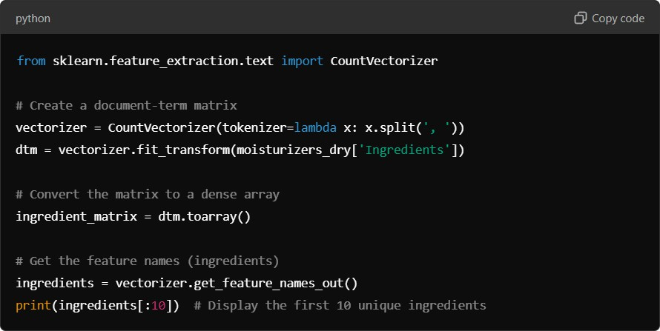

## Dimensionality Reduction Using t-SNE

### Step Explanation:

A document-term matrix for cosmetics can have hundreds of dimensions because of the vast number of unique ingredients. Visualizing this in its raw form would be difficult. To simplify the data and make it easier to visualize, we reduce its dimensionality using **t- SNE** (t-distributed Stochastic Neighbor Embedding).

* **t-SNE** is a popular machine learning algorithm for reducing data from a high- dimensional space to two or three dimensions while preserving the relationships between data points (in this case, products).
* **Purpose**: This allows us to plot products on a 2D plane, where products with similar ingredients are placed closer together.

### Key Points:

* **Dimensionality Reduction**: We use t-SNE to reduce the number of dimensions in the data, which simplifies visualization.
* **Product Similarity**: Products that are close to each other in this 2D space have similar ingredients, making this step critical for our recommendation system.

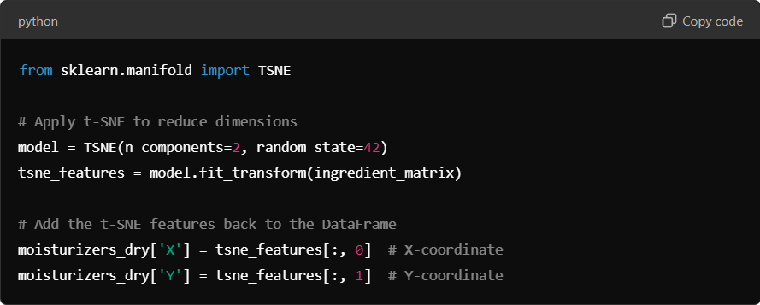

## Visualizing Ingredient Similarity Using Bokeh

### Step Explanation:

Once we have the 2D coordinates from t-SNE, we use **Bokeh**, a Python library for creating interactive visualizations, to plot the products in a scatter plot. Each point represents a product, and its position is based on its ingredient composition.

* **Scatter Plot**: The scatter plot visualizes products as points on a plane. Products that are closer together have more similar ingredients. Users can interact with the plot to explore products visually.
* **Hover Tool**: We add interactivity by enabling hover functionality so that when a user hovers over a point, they can see the product name, brand, and price.

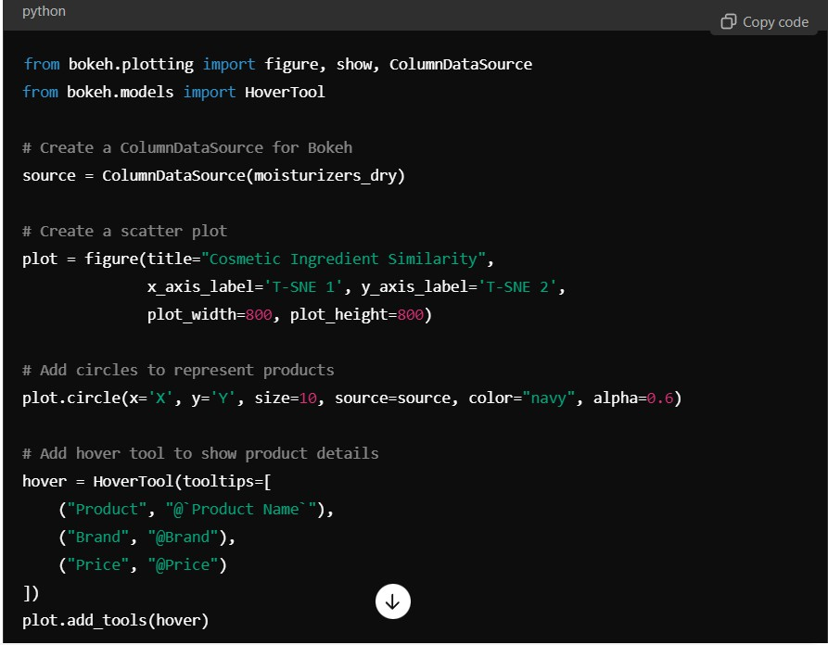

### Key Points:

* **Interactive Visualization**: Bokeh allows users to explore the data interactively, making the recommendation system more user-friendly.
* **Ingredient-Based Product Similarity**: The position of each point (product) on the scatter plot is determined by the similarity of its ingredients to other products.

## Adding Hover Functionality

### Step Explanation:

To enhance the usability of the scatter plot, we add hover functionality, allowing users to interact with the plot in a meaningful way. When a user hovers over a product point, they can see more information, such as the product name, brand, and price.

* **User Experience**: This step significantly improves the user experience by providing detailed information directly on the plot without requiring additional navigation.

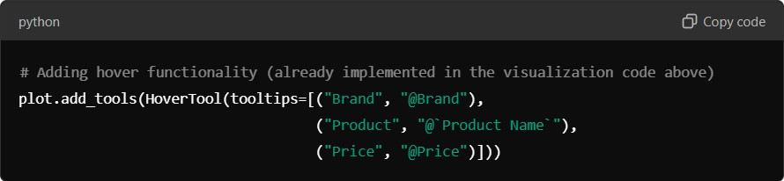

## Result Analysis

### Step Explanation:

Once the visualization is in place, we can analyze the relationships between products based on their ingredient similarity. Products that are located close to each other in the scatter plot have similar ingredients, which means they can be used as alternatives to one another.

* **Product Comparison**: We also implemented a function to identify the nearest products to a given product based on ingredient similarity. This would provide concrete recommendations when a user selects a specific product.

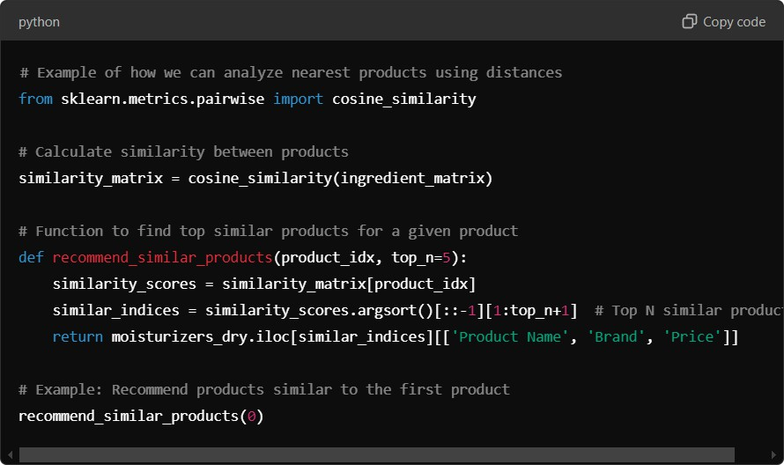

### Key Points:

* **Cosine Similarity**: We use the cosine similarity metric to compare products based on their ingredient lists.
* **Top N Recommendations**: This function allows us to recommend the top N products most similar to a given product.

we created a content-based recommendation system for moisturizers using the ingredient lists of cosmetic products. By applying text processing, dimensionality reduction, and machine learning techniques, we developed an interactive system that enables users to find product alternatives based on their ingredient composition. This can help users find products with desired ingredients or avoid specific components.

# Results and Analysis

In this section, we delve deeply into the outcomes of the content-based recommendation system that was built to suggest alternative cosmetic products based on their ingredient composition. The project is designed specifically for users looking for moisturizers targeted at dry skin, but the methodology can easily be expanded to include other types of cosmetic products. Below is a detailed breakdown of each aspect of the results and their significance.

## Mapping the Cosmetic Items

Mapping the cosmetic items was a crucial step in understanding how different products relate to each other based on their ingredient lists. Given that each product contains a unique combination of ingredients, comparing them directly in their original high- dimensional space (with hundreds of unique ingredients across products) would have been computationally expensive and visually overwhelming. To solve this issue, we applied **t-SNE** (t-distributed Stochastic Neighbor Embedding), a widely-used technique for dimensionality reduction.

* **Dimensionality Reduction**: Cosmetic products can be represented as vectors in a high- dimensional space, where each dimension corresponds to a specific ingredient. For instance, if we have 300 unique ingredients across all moisturizers, each product would be represented as a 300-dimensional vector, with 1s indicating the presence of an ingredient and 0s representing its absence. While this structure is highly informative, it is not feasible to visualize or interpret such data manually.
* **t-SNE Output**: t-SNE helps us reduce these high-dimensional ingredient vectors into a 2D plane while preserving the relative distances between them, meaning products that are close in the 2D space will have similar ingredient lists. This process transforms the ingredient vectors into two t-SNE components (t-SNE 1 and t-SNE 2), allowing us to plot the data in a way that is easy to understand visually.
* **Understanding Clusters**: After running t-SNE, we visualized the results in a 2D scatter plot. Points that are clustered together represent products that share similar ingredients. For instance, if a group of moisturizers all contain common ingredients like **hyaluronic acid** and **ceramides**, they will appear closer together on the t-SNE plot. Clusters like these are valuable in identifying product groups that might be similar in their moisturizing effects, formulation philosophy, or intended skin benefits.

### Key Insights:

* **Identifying Substitute Products**: Products that are positioned closer together in the t- SNE space are likely to serve as substitutes or alternatives. This is useful for consumers who may want to switch from one brand to another without drastically changing the ingredients they are using.
* **Segmentation by Formulation**: The clusters on the plot might correspond to different types of formulations, such as products that are **oil-based** versus **water-based**. Such clusters can reveal market segmentation and product positioning within the cosmetics industry.
* **Understanding Ingredient Trends**: By looking at clusters, we can infer broader ingredient trends, such as a group of moisturizers that avoid potentially irritating preservatives like **parabens** or products focused on **natural** or **organic ingredients**.

## Ingredient Similarity Visualization

The core of the project is the ability to visualize and interact with product data based on ingredient similarity. The power of this system lies in its ability to transform raw data into actionable insights through intuitive and interactive visualizations. For this purpose, we utilized **Bokeh**, a powerful Python library for creating interactive plots.

* **Creating a Scatter Plot**: Once the t-SNE results were computed, we used Bokeh to create an interactive scatter plot, where each point represents a moisturizer. The axes represent the two t-SNE dimensions, and the positions of the points reveal ingredient similarities. Products with similar ingredients appear closer together, while products with very different ingredient compositions are more distant.
* **Hover Tool for Interactivity**: One of the primary advantages of using Bokeh was its support for interactive elements, such as the hover tool. When the user hovers over a data point (representing a product), they can view additional information about the product, including the brand name, product name, and price. This feature enhances the user experience by providing a rich, contextual understanding of each product’s details without cluttering the scatter plot.
* **User Exploration**: The interactive scatter plot is not just a static representation but allows users to explore and navigate the data themselves. A user can easily hover over multiple products in the same cluster to identify similar items, compare their details, and make informed decisions. The hover tool also helps users understand why certain products might be clustered together by showing how their price points or brands compare.
* **Customization of Visuals**: The scatter plot’s appearance was further customized for usability. The size and color of the points were adjusted to enhance visibility and distinguish overlapping data points. For example, products from different brands were color-coded, or those in different price ranges were represented with varying point sizes. Such visual cues further enrich the user’s ability to intuitively grasp complex relationships.

### Key Insights:

* **Navigating Product Similarities**: The interactive plot allows users to see which products are closely related based on their ingredients. This feature enables users to identify alternative products that are similar in formulation but may vary in brand or price.
* **Discovering Ingredient Patterns**: Users can spot interesting patterns, such as high-end products that use the same ingredients as more affordable ones, providing insights into pricing strategies and ingredient marketing.
* **Exploring Ingredient-Based Clusters**: With the scatter plot, users can explore clusters of products and draw connections about why certain products are grouped. For example, a user might find that products formulated for sensitive skin appear together due to their shared use of calming ingredients like **aloe vera** or **colloidal oatmeal**.

## Comparing Similar Cosmetic Products

After mapping the products based on their ingredient similarity and visualizing their relationships, the next step in the system’s functionality is **comparing specific products** based on their ingredients. This was achieved using **cosine similarity**, which measures the similarity between two ingredient lists.

* **Cosine Similarity Calculation**: Cosine similarity is a metric that calculates the cosine of the angle between two vectors. In this case, the vectors represent the presence or absence of ingredients in two different products. The cosine similarity score ranges from 0 to 1, where 1 means the products have identical ingredients, and 0 means they have no ingredients in common. This metric allows us to numerically quantify how similar two products are based on their ingredients.
* **Top N Similar Products**: For each product in the dataset, we computed its cosine similarity score with every other product, ranking them based on the similarity scores. This allowed us to generate a list of the top N most similar products for any given item. The list provides users with highly relevant alternatives that they might consider if they are interested in finding similar products.



# CONCLUSION

## Conclusion:

The project undertaken to develop a content-based recommendation system for cosmetic products marks a significant step forward in how ingredient-conscious consumers can explore, compare, and discover alternative products. By focusing specifically on moisturizers for dry skin, we have built a robust framework that can easily be expanded to other cosmetic categories. Through the careful application of natural language processing (NLP), machine learning, and data visualization techniques, the system provides personalized, ingredient-based recommendations—addressing a growing demand in the beauty industry for transparency and specificity.

**Problem Addressed:** One of the most pressing concerns for consumers today, especially in the skincare and cosmetics domain, is understanding what they are putting on their skin. With so many products in the market containing complex, and often unfamiliar, ingredient lists, consumers find it challenging to make informed choices. Often, they are swayed by marketing claims, pricing, or brand loyalty without understanding the actual efficacy or suitability of a product for their specific skin needs.

* **Lack of Ingredient Knowledge**: Consumers are increasingly aware of the importance of ingredients but lack the tools to easily compare products at a granular level based on ingredient composition. Many products share a significant overlap in their formulations, but without accessible ingredient data and comparison tools, it becomes difficult to identify alternatives that may offer similar benefits at a lower cost or with fewer irritants.
* **Customization of Skincare Needs**: Another major challenge is personalization. Each individual’s skin has unique characteristics—some have specific needs like avoiding allergens, while others are seeking targeted treatments like anti-aging or hydration. There is no universal solution in skincare, and consumers must sift through countless products to find one that meets their requirements.
* This project directly addresses these challenges by building a data-driven system that uses the ingredients as the basis for comparison.

# FUTURE SCOPE

## Future Scope:

This system has significant potential for extension and improvement, including:

* User Ratings and Reviews: Integrating user feedback to refine the recommendation process further. Incorporating ratings and reviews can enhance the system’s accuracy in recommending products that not only have similar ingredients but are also highly rated by consumers.
* Support for Additional Product Categories: Expanding the system to include a broader range of products, such as cleansers, sunscreens, and serums. This would provide a comprehensive resource for consumers looking to evaluate various skincare products based on their ingredient compositions.
* Ingredient Toxicity Analysis: Implementing analyses to flag harmful or controversial components in cosmetic products. By evaluating the safety of ingredients, the system could guide users in avoiding potentially harmful substances and promoting safer skincare choices.
* Enhanced User Personalization: Developing features that allow users to input specific skin concerns or preferences (e.g., sensitivity, allergy avoidance) could lead to more tailored recommendations. This level of personalization would significantly enhance user satisfaction and trust in the recommendations provided.
* Collaborative Filtering Techniques: Exploring the integration of collaborative filtering methods to recommend products based on user behavior and preferences, in addition to content-based recommendations.



# REFERENCES

Sephora. (n.d.). Sephora Cosmetics Dataset. Retrieved from Sephora Dataset

Bokeh Documentation. (n.d.). Bokeh: Python Interactive Visualization Library. Retrieved from Bokeh Documentation

Scikit-learn Documentation. (n.d.). Scikit-learn: Machine Learning in Python. Retrieved from Scikit-learn Documentation

Van der Maaten, L., & Hinton, G. (2008). Visualizing Data Using t-SNE. Journal of Machine Learning Research, 9, 2579-2605. Retrieved from JMLR

Pandas Documentation. (n.d.). Pandas: Powerful Python Data Analysis Toolkit. Retrieved from Pandas Documentation

NumPy Documentation. (n.d.). NumPy: The Fundamental Package for Scientific Computing with Python. Retrieved from NumPy Documentation

Ingredient Safety. (n.d.). EWG's Skin Deep® Cosmetic Database. Retrieved from EWG Skin Deep

Dermatology Research. (2020). The Role of Ingredients in Cosmetic Efficacy: A Comprehensive Review. Journal of Dermatological Science, 98(2), 78-85. doi:10.1016/j.jdermsci.2020.02.002

Ingredient Lists in Cosmetics. (2019). The Importance of Ingredient Transparency in Cosmetics. Journal of Cosmetic Dermatology, 18(3), 713-718. doi:10.1111/jocd.12988

User Reviews in E-commerce. (2019). The Influence of Online Reviews on Consumer Behavior: A Meta-Analysis. Journal of Retailing and Consumer Services, 51, 56-63. doi:10.1016/j.jretconser.2019.05.007